**Prepare Material Claims Workbook Instructions**

1. Open BAAN
   1. File – Run Program.
   2. Enter tipcs9610m000 in the Program/Session field.
   3. Click OK.
   4. 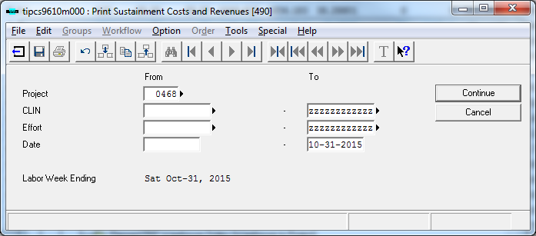
   5. In the project field – enter the project you need
      1. Example: LCS 5 – Enter 0466
      2. Example: LCS 7 – Enter 0468
   6. Click tab until you get to the To Date. Enter the current reporting period month end date.
   7. Click tab to the Continue button.
   8. Click Continue.
   9. When a box appears with Report – Click Sustainment Costs and Revenues – Excel.
   10. When Select Device Box appears – Click the arrow so the device is selected as b2Win.
   11. Click Continue.
   12. When b2Win 8.5 box appears, click the green Run button.
   13. When the report appears: File – save as – 04XX MMM YYYY Material Actual Costs in the respective ship actual costs folder which is listed under Cobra Processing: (Example: 0466 Aug 2016 Material Actual Costs).
   14. Open the following for the respective ship:
   15. Go back into the report that has just been run.
   16. Copy Column A through Column P and paste into 04XX to 04XX Costs MMM-YYY ‘Material Raw Data Paste’ tab.
   17. Highlight this tab a different color after pasted in.